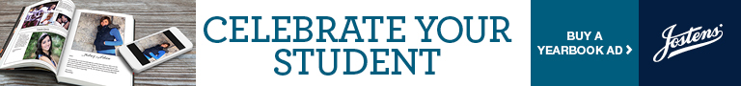

Dear Parents:

Senior Year! A Monumental Year for both Students and their Families!

Josten’s has opened up our Senior Ad Builder and it is a very easy way to design a template, upload pictures and insert text to celebrate and create a lasting memory of your Senior’s accomplishments in their final high school yearbook. This ad builder will remain open until November 30, 2020.

The attachments to this email include: Ad Sizes/Prices, payment information and complete directions on how to create your ad.
It’s very simple!!
A direct link to Josten’s/Yearbook Ad is: https://www.jostens.com/apps/jcom/router.mvc?affiliateId=1486092

If you have any questions, please let me know. Ads must be completed by the deadline of November 30, 2020 to ensure their placement in our book.

Thanks! Sharon Mews,
Yearbook Advisor/Editor
Sussex Academy
sharon.mews@saas.k12.de.us

