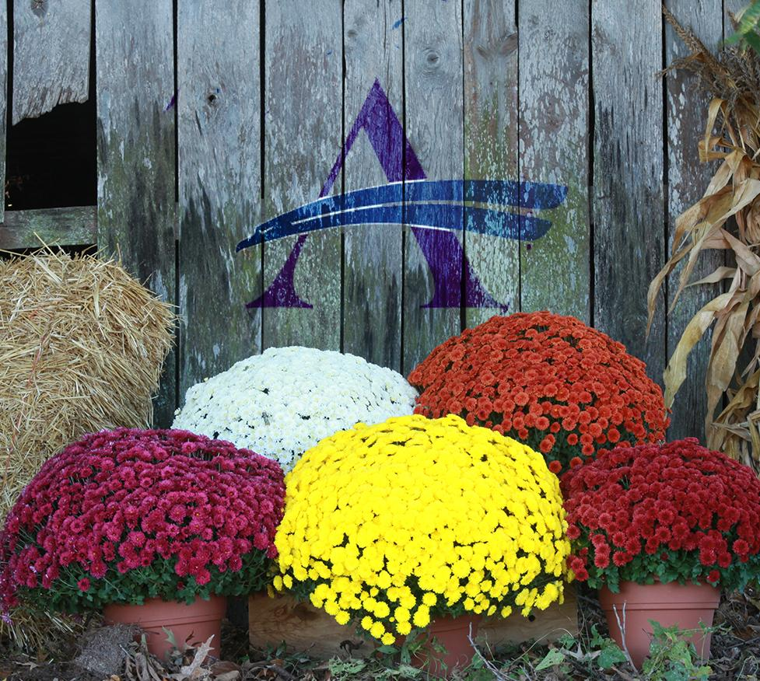
Sussex Academy
Sports Boosters Presents

Fall 2020 Mum Fundraiser

Benefits Sussex Academy
Student Athletes

The Sussex Academy Sports Boosters are sponsoring a fall chrysanthemum sale from September 15th through September 28th. Mums are grown in large 9” pots and are $7.00 each.

There are TWO locations to pick-up your mums: at Lakeside Greenhouses in Laurel (during normal business hours) or at Sussex Academy on October 1st from 3:30 pm to 6 pm.

A variety of colors will be available on a first come, first serve basis when picking up at the school. For the best selection in Laurel, plan to pick them up prior to October 19th.

Ordering - Given the short turnaround and for COVID protocols, please fill out the form below and return it via email to sussexacademysportsboosters@gmail.com.

Payment – Credit Card via Paypal (sussexacademysportsboosters@gmail.com) or Venmo (@SA Sports Boosters) If paying by check (Payable to SA Sports Boosters) or cash, please mail payment and order form to 21150 Airport Road Georgetown, DE 19947 – Attn: Sports Boosters

NO VOUCHERS NEEDED THIS YEAR. Lakeside will be given a list of pick – ups.

Customer’s name: __________________________________ Phone: ______________________

Student’s name: _____________________ Grade: ____ Email: ____________________________

Check ONE LOCATION for mum pickup:

____ I will pick up my mums at Sussex Academy on Thursday, Oct 1st (3:30 pm – 6 pm)

____ I will pick up my mums voucher at Lakeside Greenhouses in Laurel (prior to Oct 19th)

Quantity | Item | Price each | Amount Due
 | 9” Mum | $7.00

