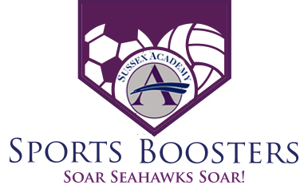

12/09/19 Meeting Minutes
5pm – Sussex Academy Weight Room

Attendees:

Nikki Basile, Nicole Lehman, Thad Mcllvaine, Steve Bastianelli, Candace Hickman, Suzayn Mooney, CW Mitchell

Minutes from last meeting:
No proposed changes. The meeting minutes will be current on the SA website under the parent tab. You will see a sports boosters link.
Budget/Treasurer’s Report:
Balance including sub-accounts: $42,151.09
Balance excluding sub-accounts: $19,578.59
- 501c Status Update – No change
- Deposits and Expenses
  - Questions regarding soccer account balance – Thad/Suzayn to follow up with discussing any discrepancies.
- 2019/2020 Budget Process
  - Nikki still working on putting together format to be utilized moving forward.
  - Retroactive budget being produced for 2019/2020
Old Business:

Liaison Reports
- Discussed need for Indoor Track, Basketball & Swimming Liaisons – CW to co-liaison with Christine Elling for swimming

Committee Reports
- Concessions Committee – Lisa (need winter season concession help)
- Sports Program Committee – Nikki (Still looking for committee member)
- Senior Banner Committee/Senior Night Committee – Nikki (Still looking for committee member)
- General Fundraisers – Mums, Gift Cards, Wreaths – Candace Hickman/ Kris Hagy
- Special Events Committee - Homecoming, Sports Kick Off, End of Year All Sport Banquet – Nikki (Still need committee chair and committee members)

New Business:

- Wreath Fundraiser Update - Nikki B.
- Live Now till 12/15
- Current Profit - $476 (As of 12/09)

- Gift Card Fundraiser – Nikki B.
  - Gift Cards delivered 12/11
  - Gift Cards distribution 12/13
  - Profit - $727

- Fundraiser Calendar - Nicole
- Discussed potential fundraising calendar – Some members believe that we need to come up with a different idea. We need to develop a spring fundraiser in order to raise additional funds for general account

- Winter Program – Nikki B
  - Steve working on photos

- Winter Senior Banners – Nikki B.
- Nikki to work on dates for photos

- New Fundraiser & Request Procedures – Nikki
- Reviewed documents to be used to request new fundraisers
- Reviewed documents to be used for communications via email/facebook/weekly update – Nikki is the gatekeeper for these items.
- Nikki to set up a meeting in the new year with Gina, Eric, and Duncun Smith to discuss sports boosters fundraising and allocation of budgets.
Next meeting date:
Wed – 1/13 -5:00pm

