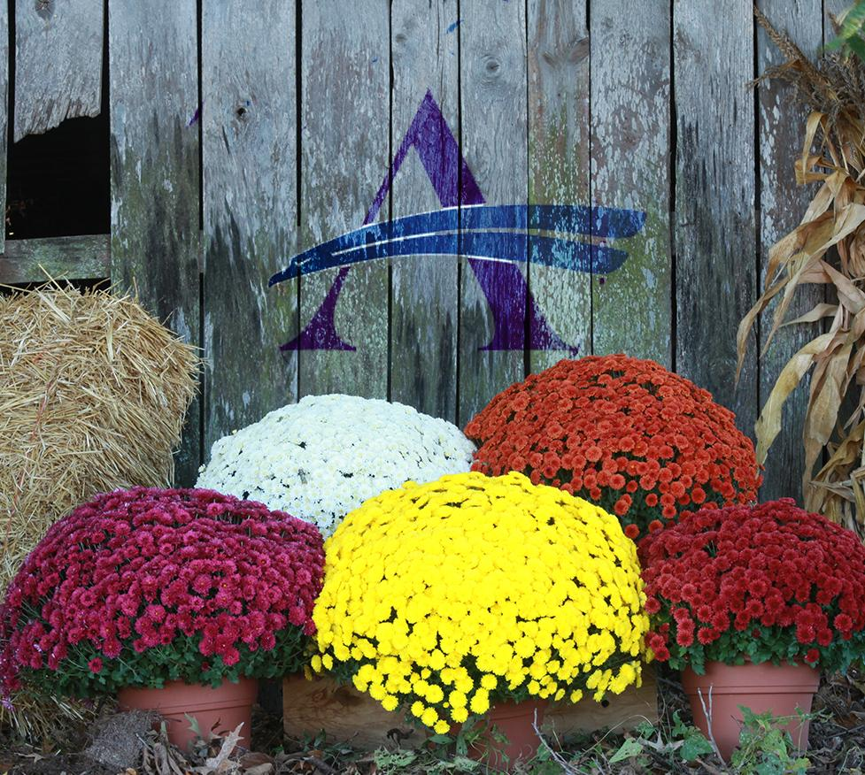
Sussex Academy
Sports Boosters Presents

Fall 2019 Mum Fundraiser

Benefits Sussex Academy
Student Athletes

The Sussex Academy Sports Boosters are sponsoring a fall chrysanthemum sale from September 9th through September 20th. Mums are grown in large 9” pots and are $7.00 each.

There are TWO locations to pick-up your mums: at Lakeside Greenhouses in Laurel (during normal business hours) or at Sussex Academy on September 26th from 3 pm to 6 pm.

A variety of colors will be available on a first come, first serve basis when picking up at the school. For the best selection in Laurel, plan to pick them up prior to October 19th.

Please fill out the form below and return it along with payment to homeroom teachers by Friday, September 20th. Alternatively, completed orders can be emailed to sussexacademysportsboosters@gmail.com

Vouchers will be sent home with students or emailed the week of September 23rd and are required to pick up your mums at both locations.

Customer’s name: __________________________________ Phone: ______________________

Student’s name: _______________________ Grade: ____ Homeroom Teacher: ______________

Check ONE LOCATION for mum pickup:

____ I will pick up my mums at Sussex Academy on Thursday, Sept. 26 (3 pm – 6 pm)

____ I will use my mums voucher at Lakeside Greenhouses in Laurel (prior to Oct 19th)

Quantity | Item | Price each | Amount Due
 | 9” Mum | $7.00

Make checks payable to SA Sports Boosters or Credit Card payments via Paypal – Sussexacademysportsboosters@gmail.com

