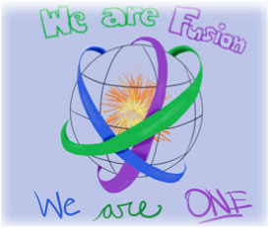
September 12th, 2018 Team Fusion – Homework

Math: A. Guided Practice-pg. 34, 1-6 all
B.TEST- SECTIONS 1.1 & 1.2
-Bring a calculator (does not have to be scientific)
-One index card- conversions ONLY
Pd. 4 & 5 : WORKSHEET AND BOOK HOMEWORK WILL BE CHECKED NEXT CLASS
4TH PERIOD CLASS- bring Summer Packet Next Class!!!
Reading: List your three favorite fictional characters and give three different characteristics for each. What makes the character likeable or unlikeable?

Science:
Pd 1 and 3: Finish graph (including all components discussed in class) and answer reflection questions #1-4 in Inv 1.
Pd 2: Finish graph (including all components discussed in class
Pd 4, 5: None

Social Studies: 1, 2, 3 = INB p. 92, need US
4, 5 = INB p. 88
INB Collection starts Monday; 40 pts

Writing: No Red Ink assignment due 9/19.
Commonly confused words quiz 9/19.

Portfolio/Homeroom/Miscellaneous:
Goal setting sheet signed. Due Thursday.

Week of 9/10:
Monday, Wednesday, Friday – A day; Tuesday, Thursday- B day

