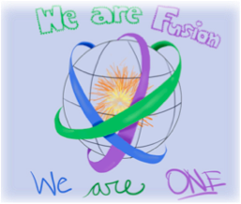
October 5, 2018 Team Fusion – Homework

Math: pd. 1,2 &3: A) Worksheet: put problems on loose leaf- 58,62,64
& 66. B). TRANSLATING ALGEBRAIC EXPRESSIONS WRKSHEET- BOTH SIDES
pd. 5: pg 61 problems 2-19, pg 63 problems 27-32 and worksheet (MULTIPLYING BY-1 and removing parenthesis)
Pd 4 Advanced Order of Operations Worksheet- both sides- SHOW WORK!!!
NO CALCULATORS!!!

Reading: A day: CSET draft due Monday. Final due Wednesday. Reading log due 10/15. B day: CSET draft due Tuesday. Final due Thursday. Reading log due 10/16

Science:
None

Social Studies: 1, 2, 3 = Finish CW INB p. 114-115; INB p. 116
4, 5 = Finish CW INB p. 114-115; INB p. 116

Writing:
Type third draft of braided essay incorporating research.
Upfront password is mixhint1.

Portfolio/Homeroom/Miscellaneous
Week of 10/8:
Monday, Wednesday - A day; Tuesday, Thursday- B day; Friday – Inservice day

